

U20CS702-INTERNET OF THINGS
UNIT I FUNDAMENTALSOFIOT
PART A

1. Define Iot?

The internet of things (IoT) is a computing concept that describes the idea of everyday physical objects being connected to the internet and being able to identify themselves to other devices. It has dynamic global network infrastructure with self-configuring capabilities based on standard and interoperable communication protocols where physical and virtual “things” have identities, physical attributes and virtual network and use intelligent interfaces.

2. List of Iot protocols?

Link Layer

802.3 – Ethernet,802.11 – WiFi ,802.16 – WiMax ,802.15.4 – LR-WPAN,2G/3G/4G

Network/Internet Layer

IPv4,IPv6,6LoWPAN

Transport Layer

TCP,UDP

Application Layer

HTTP, CoAP ,WebSocket ,MQTT,XMPP,DDS,AMQP

3. List the applications of Iot?
- Smart Grids
- Smart cities
- Smart homes
- Healthcare
- Earthquake detection
- Radiation detection/hazardous gas detection
- Smartphone detection
- Water flow monitoring.

4. List Iot communication model?
1. Request-Response communication model
2. Publish-Subscribe communication model
3. Push-Pull communication model
4. Exclusive Pair communication model
5. Iot enabling technologies?
1. Wireless Sensor Networks
2. Cloud Computing
3. Big Data Analytics
4. Embedded Systems

6. what are the characteristics of IOT

Massively scalable and efficient, IP-based addressing will no longer be suitable in the upcoming future.

Devices typically consume less power. When not in use, they should be automatically programmed to sleep.

A device that is connected to another device right now may not be connected in another instant of time.

Intermittent connectivity – IoT devices aren’t always connected. In order to save bandwidth and battery consumption, devices will be powered off periodically when not in use. Otherwise, connections might turn unreliable and thus prove to be inefficient.

7.List different services used in cloud computing

Infrastructure as a service (IaaS): Provides access to computing resources such as servers, storage, and networking.

Platform as a service (PaaS): Provides a platform for developing and deploying applications without managing the underlying infrastructure.

Software as a service (SaaS): Provides access to software applications that run on the cloud and are delivered over the internet.

Function as a service (FaaS): Provides a way to execute functions in response to events or requests.

What are the different types of IOT protocols.

The wireless hardwares used in IoT are the nodes and the base stations. Nodes or clients are the devices that connect to the base stations. Base stations are the routers or gateways. We will discuss the protocols used between these devices

IoT protocols are briefly classified into two types:

IoT data protocols

IoT Network Protocols

What is the role of things and Internet in IOT

It is the web of physical objects or things equipped with sensors, software, and connected to the internet. The IoT lets devices communicate and share data to ease workflow processes.

Devices in the IoT include things as small as a pill and as major as jet engines

What is the advantages & disadvantages of an IOT

Advantages
- Improved efficiency and automation of tasks.
- Increased convenience and accessibility of information.
- Better monitoring and control of devices and systems.
- Greater ability to gather and analyze data.
- Improved decision-making.
- Cost savings.
Disadvantages:
- Security concerns and potential for hacking or data breaches.
- Privacy issues related to the collection and use of personal data.
- Dependence on technology and potential for system failures.
- Complexity and increased maintenance requirements.
- High initial investment costs.
- Limited battery life on some devices.

List out some components are used in wsn?
- Sensors:
Sensors in WSN are used to capture the environmental variables and which is used for data acquisition. Sensor signals are converted into electrical signals.
- Radio Nodes:
It is used to receive the data produced by the Sensors and sends it to the WLAN access point. It consists of a microcontroller, transceiver, external memory, and power source.
- WLAN Access Point:
It receives the data which is sent by the Radio nodes wirelessly, generally through the internet.
- Evaluation Software:
The data received by the WLAN Access Point is processed by a software called as Evaluation Software for presenting the report to the users for further processing of the data which can be used for processing, analysis, storage, and mining of the data.

12. List the features of IOT
The most important features of IoT on which it works are connectivity, analyzing, integrating, active engagement, Artificial Intelligence, Sensing,Endpoint Management.

13. What is cloud computing
The term cloud refers to a network or the internet. It is a technology that uses remote servers on the internet to store, manage, and access data online rather than local drives. The data can be anything such as files, images, documents, audio, video, and more.

14. Define Big data Analytics
Big data analytics is the process of collecting, examining, and analyzing large amounts of data to discover market trends, insights, and patterns that can help companies make better business decisions.

15. What are the Tools are used in Big data Analytics
- Hadoop
- Spark
- Data integration software
- Stream analytics tools
- Distributed storage
- Predictive analytics hardware and software.
- Data mining tools
- NoSQL databases
- Data warehouses
16. What are the functions of analytic in Cloud services

- Data Collection and Integration
- Data Storage and Management
- Data Processing and Transformation
- Descriptive Analytics
- Diagnostic Analytics
- Predictive Analytics

17. List Components of IoT Architecture
- Sensors/Devices
- Gateways and Networks
- Cloud/Management Service Layer
- Application Layer

18. Give the evolutionary phases of IoT
- Stage 1: Sensors and Actuators;
- Stage 2: Gateways and Data Acquisition Systems;
- Stage 3: Edge IT Data Processing;
- Stage 4: Data center and Cloud;

19. Pointout the challenges faced by Internet of Things.
- Lack of security and privacy for users and data
- Heterogeneity and compatibility of different devices and platforms
- Storage and energy issues for large-scale data processing and transmission
- Waste disposal and environmental impact of obsolete devices
- Quality of service and intelligent analysis and actions for IoT application

20. Define Wireless Sensor Networks.
- Wireless Sensor Network (WSN) is an infrastructure-less wireless network that is deployed in a large number of wireless sensors in an ad-hoc manner that is used to monitor the system, physical or environmental conditions. Sensor nodes are used in WSN with the onboard processor that manages and monitors the environment in a particular area
PART B

- Describe the levels of IoT with the help of neat diagrams give an example of each
- Describe how wireless sensor networks became one of the enabling technologies of IoT.
- Discuss the role of communication protocols and embedded systems in IoT.
- Explain the characteristics and application of IOT in detail [10]?
- Explain different types of IOT communication model [15]
- Explain IOT Enabling Technologies with diagram?[15]
- Brief about logical design of IOT?[5]
- Explain about IOT communication API?[15]
- Explain about IOT Level-6 with block diagram?[10]
- Brief about physical devices of IOT?

UNIT II

Part A

1. What is M2M?

Machine-to-Machine (M2M) • An M2M area network comprises of machines (or M2M nodes) which have embedded hardware modules for sensing, actuation and communication. Various communication protocols can be used for M2M local area networks such as ZigBee, Bluetooh, ModBus, M-Bus, Wirless M-Bus, Power Line Communication (PLC), 6LoWPAN, IEEE 802.15.4, etc.

2.Difference between M2M and Iot?

Difference between IoT and M2M :

Hardware vs Software Emphasis

• While the emphasis of M2M is more on hardware with embedded modules, the emphasis of IoT is more on software.

• Data Collection &Analysis :

M2M data is collected in point solutions and often in on-premises storage infrastructure. In contrast to M2M, the data in IoT is collected in the cloud (can be public, private or hybrid cloud).

Applications: M2M data is collected in point solutions and can be accessed by on-premises applications such as diagnosis applications, service management applications, and on- premisis enterprise applications.

• IoT data is collected in the cloud and can be accessed by cloud applications such as analytics applications, enterprise applications, remote diagnosis and management applications, etc.

3.What are the two types of networking software?

SDN- Software-Deﬁned Networking

NFV- Network Function Virtualization.

4.Need for IoT Systems Management?

Automating Configuration

Monitoring Operational & Statistical Data

Improved Reliability

System Wide Configurations

Multiple System Configurations

Retrieving & Reusing Configurations

5.Discuss about SNMP?

Simple Network Management Protocol (SNMP) • SNMP is a well-known and widely used network management protocol that allows monitoring and conﬁguring network devices such as routers, switches, servers, printers, etc.

6.Network Operator Requirements?
- Ease of use
- Distinction between configuration and state data
- Fetch configuration and state data separately
- Configuration deltas
- Dump and restore configurations
- Configuration validation • Configuration database schemas
- Comparing configurations • Role-based access control • Consistency of access control lists: • Multiple configuration sets • Support for both data-oriented and task- oriented access control.

7.About NETCONF?
Network Configuration Protocol (NETCONF) is a session-based network management protocol. NETCONF allows retrieving state or configuration data and manipulating configuration data on network devices .

8.About YANG?
YANG is a data modelling language used to model configuration and state data manipulated by the NETCONF protocol ,YANG modules contain the definitions of the configuration data, state data, RPC calls that can be issued and the format of the notifications.
9.Mention the communication protocols used for M2M local area networks
Various communication protocols can be used for M2M local area networks such as ZigBee, Bluetooth, ModBus, M-Bus, Warless M-Bus, Power Line Communication (PLC), 6LoWPAN, IEEE 802.15.4, e
10.Define Software defined Network
SDN stands for Software Defined Network which is a networking architecture approach. It enables the control and management of the network using software applications. Through Software Defined Network (SDN) networking behavior of the entire network and its devices are programmed in a centrally controlled manner through software applications using open APIs. To understand software-defined networks, we need to understand the various planes involved in networking.
- Data Plane
- Control Plane
- Define Network Function Virtualization
Network functions virtualization (NFV) is the replacement of network appliance hardware with virtual machines. The virtual machines use a hypervisor to run networking software and processes such as routing and load balancing.
- List out the key elements of NFV architecture
Key elements of the NFA architecture are as follows:
- Virtualized Network Function
- NFA Infrastructure(NFVI)
- NFA management and Orchestration
- Benefits of NFV
- Many service providers believe that advantages outweigh the issues of NFV.
- Traditional hardware-based networks are time-consuming as these require network administrators to buy specialized hardware units, manually configure them, then join them to form a network. For this skilled or well-equipped worker is required.
- It costs less as it works under the management of a hypervisor, which is significantly less expensive than buying specialized hardware that serves the same purpose.
- Easy to configure and administer the network because of a virtualized network. As a result, network capabilities may be updated or added instantly.

14.Components of Software Defining Networking (SDN)
- SDN Applications
- SDN controller
- SDN networking devices
15.List Three layers of SDN architecture
- Application layer: It contains the typical network applications like intrusion detection, firewall, and load balancing.
- Control layer: It consists of the SDN controller which acts as the brain of the network. It also allows hardware abstraction to the applications written on top of it.
- Infrastructure layer: This consists of physical switches which form the data plane and carries out the actual movement of data packets.
16. Limitations of SNMP
- NMP is stateless in nature and each SNMP request contains all the information to process the request. The application needs to be intelligent to manage the device.
- SNMP is a connectionless protocol which uses UDP as the transport protocol, making it unreliable as there was no support for acknowledgement of requests.
- SNMP may not be suitable for the management of truly large networks because of the performance limitations of polling.
- SNMP is not well suited for retrieving large volumes of data, such as an entire routing table.
- SNMP traps are unacknowledged and may not be delivered.
17.What are all the steps involved in IOT design methodology?
Step 1:Purpose& Requirements Specification.
Step 2:ProcessSpecification
Step 3:Domain Model Specification
Step 4:Information model specification
Step 5:Service specifications
Step 6:IoT Level specification
Step 7:Functional view specification
Step 8:Operational view specification
Step 9:Device $ Component integration
Step 10:Application Development.
18.List out commonly used NETCONF RPC methods and its description
Connect-connect to a NETCONF server
get-Retrieve the running configuration and state information
get-config-Retrieve all or a portion of a configuration datastore.
Edit-config-Loads all or part of a specified configuration to the specified target configuration
Copy-config-Create or replace an entire target configuration data store with a complete source configuration
Lock- Lock a configuration data store exclusive edits by client
Commit- commit the candidate configuration as the device’s new current configuration
Close-session-Gracefully terminate a NETCONF session
Kill-session -forcefully terminate NETCONF session
19. List out the components of SNMP
  - Network Management Station (NMS)
    - Managed Device
    - Management Information Base (MIB)
    - SNMP Agent that runs on the device
20. Write salient features of M2M protocol
  - Enables automated communication between devices without human intervention.
  - Uses lightweight protocols like MQTT or CoAP for low-power and low-bandwidth communication.
  - Supports real-time data monitoring and remote control.
  - Provides scalability, security, and interoperability across various devices and networks.

PART B
- Explain IOT device management NETCONF- YANG
- Draw and explain the architecture and components of M2M?
- Explain about NETCONF system management in detail
- List the commands used in NETCONF RPC Methods?
- Explain about YANG in detail with diagram?
- Explain difference between IOT and M2M and key application area of M2M?
- Describe the various steps involved in IoT system design methodology:
- Describe how NFV can be used for virtualizing IoT device?
- Explain SDN Architecture and how SDN can be used for various levels of IoT.
- Draw and explain NFV Architecture?
- Summarize about SNMP Management with diagram?
- List the Network Operator Requirement

UNIT III
IOT PROTOCOLS
PART A
1.Define sensor in IOT
Sensor converts a physical quantity into a corresponding voltage. sensor is a device that when exposed to a physical phenomenon(temperature,displacement,force,etc) produces a proportional output signal(electrical,mechanical,magneticetc)sensors can also be classified as passive oy active.
2.What is the specification of sensors?
- Accuracy
- Resolution
- Sensitivity
- Repeatability/precision
- Bandwidth
3.Compare sensors and actuators
SENSOR | ACTUATOR
It converts physical characteristics into electrical signals. | It converts electrical signals into physical characteristics.
It takes input from environment. | It takes input from output conditioning unit of system.
It gives output to input conditioning unit of system. | It gives output to environment

4.List Types of sensors
- Mechanical sensor
- Pheumatic sensor
- Optical sensor
- Electrical sensor
- Range sensing
5.Mention the sensor data communication protocols?
- Direct transmission protocols
- Minimum transfer energy protocols
6.Define Acuators
A device or mechanism capable of performing a physical action. Acutatorsintract with the world.sensor capture information from the world.The interface between the microcontroller and the sensors or the actuators is either analog or digital.
7.Give the Features of Zigbee
- Stochastic addressing: A device is assigned a random address and announced. Mechanism for address conflict resolution. Parents node don’t need to maintain assigned address table.
- Link Management: Each node maintains quality of links to neighbors. Link quality is used as link cost in routing.
- Frequency Agility: Nodes experience interference report to channel manager, which then selects another channel
- Asymmetric Link: Each node has different transmit power and sensitivity. Paths may be asymmetric.
- Power Management: Routers and Coordinators use main power. End Devices use batteries.
8. Types of Zigbee devices
Zigbee Coordinator Device: It communicates with routers. This device is used for connecting the devices.
Zigbee Router: It is used for passing the data between devices.
Zigbee End Device: It is the device that is going to be controlled.
- Compare ZigBee and ZigBee pro
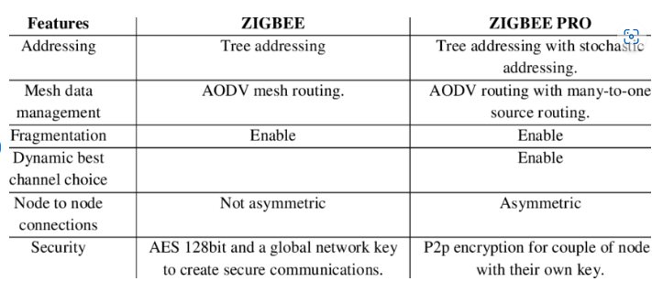

- Zigbee network topologies.
Star Topology (ZigBee Smart Energy): Consists of a coordinator and several end devices, end devices communicate only with the coordinator.
Mesh Topology (Self Healing Process): Mesh topology consists of one coordinator, several routers, and end devices.
Tree Topology: In this topology, the network consists of a central node which is a coordinator, several routers, and end devices. the function of the router is to extend the network coverage.
- Define LoRaWAN
LoRaWAN is a low-power, wide area networking protocol built on top of the LoRa radio gatewaysmodulation technique. It wirelessly connects devices to the internet and manages communication between end-node devices and network

- Draw MAC format for LoRA
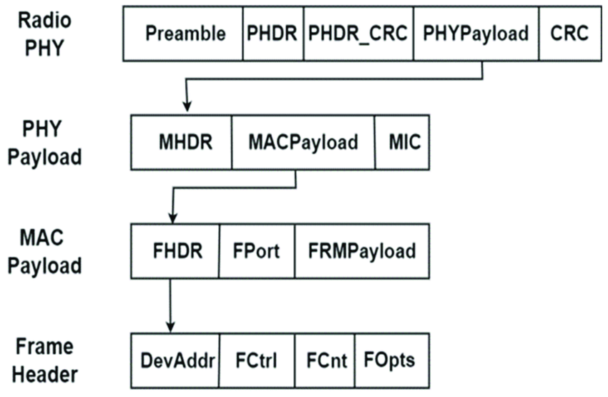
13.Definr RFID and uses
Uses. An RFID tag can be affixed to an object and used to track tools, equipment, inventory, assets, people, or other objects. RFID offers advantages over manual systems or use of barcodes. The tag can be read if passed near a reader, even if it is covered by the object or not visible.
14.Features of RFID
- An RFID tag consists of two-part which is an microcircuit and an antenna.
- This tag is covered by protective material which acts as a shield against the outer environment effect.
- This tag may active or passive in which we mainly and widely used passive RFID
15.Types of RFID
PassiveRFID –
Passive RFID tags does not have their own power source. It uses power from the reader. In this device, RF tags are not attached by a power supply and passive RF tag stored their power. When it is emitted from active antennas and the RF tag are used specific frequency like 125-134KHZ as low frequency, 13.56MHZ as a high frequency and 856MHZ to 960MHZ as ultra-high frequency.
Active RFID –
In this device, RF tags are attached by a power supply that emits a signal and there is an antenna which receives the data. means, active tag uses a power source like battery. It has it’s own power source, does not require power from source/reader.

16.Advantages and Disadvantages of RFID
Advantages
- It provides data access and real-time information without taking to much time.
- RFID tags follow the instruction and store a large amount of information.
- The RFID system is non-line of sight nature of the technology.
- It improves the Efficiency, traceability of production.
- In RFID hundred of tags read in a short time.
Disadvantages
- It takes longer to program RFID Devices.
- RFID intercepted easily even it is Encrypted.
- In an RFID system, there are two or three layers of ordinary household foil to dam the radio wave.
- Active RFID can costlier due to battery.
17.Types of Communication Model
- Request & Response Model
- Publisher-Subscriber Model
- Push-Pull Model
- Exclusive Pair
18.Difference between Sensor and Actuator
Sensor | Actuator
It converts physical characteristics into electrical signals. | It converts electrical signals into physical characteristics.
It takes input from environment. | It takes input from output conditioning unit of system.
It gives output to input conditioning unit of system. | It gives output to environment.
Sensor generated electrical signals. | Actuator generates heat or motion.
It is placed at input port of the system. | It is placed at output port of the system.
It gives information to the system about environment. | It accepts command to perform a function.
Example: Photo-voltaic cell which converts light energy into electrical energy. | Example: Stepper motor where electrical energy drives the motor.
20.what is request response communication model?
Request & Response Model – This model follows a client-server architecture.
The client, when required, requests the information from the server. This request is usually in the encoded format. This model is stateless since the data between the requests is not retained and each request is independently handled.The server Categories the request, and fetches the data from the database and its resource representation.
PART B
- Briefly Explain about Zigbee architecture
- Briefly explain about communication modules
- Write short notes on Cloud StorageModels.
- Explain RFID Protocols
- Write short notes on LoRa and WiFi
- Discuss in details about Sensor and Actuators in IOT
- Generalize the IOT Communication API’s
  - i.REST based communication API
  - ii.Web socket based communication API
- Discuss LoRa and LoRaWAN technologies. How are they used in long-range, low-power IoT applications?
- Discuss different types of power sources used in IoT devices and their impact on device performance
- Compare Zigbee, LoRa, RFID, and Wi-Fi based on range, speed, power consumption, and applications.

UNIT IV
PART A
- Examine the use and purpose of Arduino
Arduino is widely used in IoT applications for collecting sensor data, processing it, and transmitting it to the cloud for analysis and control, enabling the development of smart and connected devices and systems.
- Name the linux version on Raspberry Pi
Raspberry Pi OS is a Unix-like operating system based on the Debian GNU/Linux distribution for the Raspberry Pi family of compact single-board computers.
- Summarize on Raspberry Pi
The Raspberry Pi is a very cheap computer that runs Linux, but it also provides a set of GPIO (general purpose input/output) pins, allowing you to control electronic components for physical computing and explore the Internet of Things (IoT).
- Discuss on Arduino software program sketches
Programs written using Arduino Software (IDE) are called sketches. These sketches are written in the text editor and are saved with the file extension . ino. The editor has features for cutting/pasting and for searching/replacing text.
- Illustrate the block diagram of IoT Device.
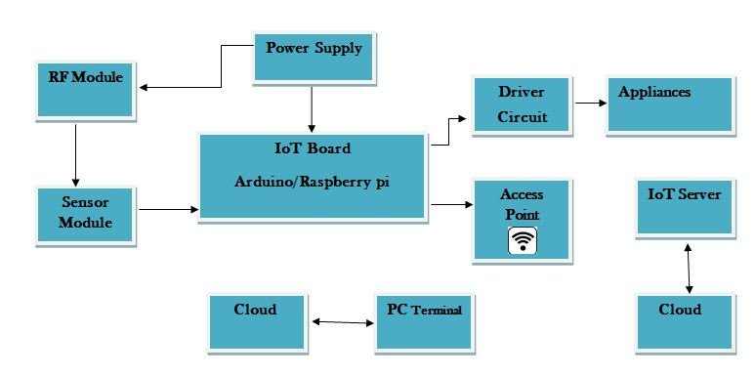
6.Discuss on interfacing LDR with Raspberry Pi.
Light Dependent Resistor is a type of resistor which changes its resistance according to the intensity of light. You can interface LDR with Raspberry Pi by using an NPN transistor. The voltage from the LDR is fed to the base of the transistor, which in turn amplifies it and sends it to a GPIO pin on the Pi
To interface an LDR with a Raspberry Pi, you need to¹²:
- Connect pin #1 (3v3) to the positive rail on the breadboard.
- Connect pin #6 (ground) to the ground rail on the breadboard.
- Place the LDR sensor onto the board and have a wire go from one end to the positive rail.
- On the other side of the LDR sensor, place a wire leading back to the Raspberry Pi. Hook this to pin #7
7.Make the circuit as per the given diagram
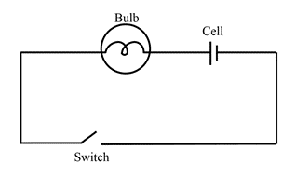

8.Analyze the interfaces in Raspberry Pi.
in an SPI connection, there are five pins on Raspberry Pi for SPI interface : MISO (Master in slave out) – Master line for sending data to the peripherals. MOSI (Master out slave in) – Slave line for sending data to the master. SCK (Serial Clock) – Clock generated by master to synchronize data transmission.
9.Summarize on the need of microcontroller in embedded system.
Embedded systems are designed to perform dedicated tasks within a larger system, often with real-time constraints and resource limitations. Microcontrollers are purpose-built for such scenarios, offering a cost-effective solution that balances performance, power consumption, and size.
10.Generalize on controlling LED with Raspberry Pi.
Controlling an LED
To connect an LED to a resistor, place the LED and resistor in series with each other. ...
Once the LED and resistor are in series with each other, you can use jumper leads to connect the circuit to the Raspberry Pi.
11.Illustrate the basic Arduino board.
The Arduino UNO board has 6 analog input pins, labeled “Analog 0 to 5.” These pins can read the signal from an analog sensor like a temperature sensor and convert it into a digital value so that the system understands. These pins just measure voltage and not the current because they have very high internal resistance.
12.Summarize on other IoT devices apart from Raspberry Pi
Libre Computer Board AML-S905X-CC (Le Potato) | Best Raspberry Pi alternative
Orange Pi 5 Plus | Best Raspberry Pi alternative for media. ...
Asus Tinker Board S R2.0 | Best Raspberry Pi alternative for hobbyists. ...
Odroid N2+ | Best Raspberry Pi alternative for power.

13.Generalize on the various chips on embedded system.
The term system on a chip (SoC) is often used. SoCs include multiple processors and interfaces on a single chip. They are often used for high-volume embedded systems. Some example SoC types are the application-specific integrated circuit (ASIC) and the field-programmable gate array (FPGA).

14.List the essential requirements for setting up Raspberry Pi.
A Raspberry Pi. The optimal model depends strongly on the processing power and connectivity required, see below. A micro-SD card of at least 8gb to store the operating system and user data. A power supply of 5V DC, with 2.5A recommended to guarantee a stable working system.

15.what is cloud services?
SaaS stands for software as a service, and it refers to a cloud-based software delivery model. It's a cloud service that enables users to access on-demand software applications via the internet rather than having to install them. Examples of these cloud applications include DropBox and Google Workspace

16.Essential characteristics of cloud services?
On-demand self-service. ...
Resource pooling. ...
Scalability and rapid elasticity. ...
Pay-per-use pricing. ...
Measured service. ...
Resiliency and availability. ...
Security. ...
Broad network access.

17.Define data virtualization in Iot
Data virtualization is an approach to data management that allows an application to retrieve and manipulate data without requiring technical details about the data, such as how it is formatted at source, or where it is physically located, and can provide a single customer view (or single view of any other entity) of .

18.Give the characteristics of python
• Easy to Read and Write – Python has simple, English-like syntax.
• Interpreted and High-Level Language – Executes code line by line and handles memory management automatically.
19. Differentiate Raspberry with Arduino.
• Raspberry Pi is a mini computer with an operating system, suitable for complex tasks like running Python or web servers.
• Arduino is a microcontroller, ideal for simple hardware projects like controlling sensors or LEDs.
20. Name any four services offered by Raspberry Pi.
• Web Server Hosting
• Home Automation
• Media Center (e.g., using Kodi)
• IoT Device Control and Monitoring

Part B
- Formulate on python programming for Raspberry Pi
- Analyze in detail an exemplary device: Raspberry Pi. Explain in detail the Raspberry Pi interfaces.
- Illustrate the arduino board details and explain the steps for installing the board
- Examine the process of using the Integrated Development Environment (IDE) to prepare an Arduino sketch.
- Discuss in detail the Interfacing LED and switch with Raspberry Pi as an example. Give the procedure
- Analyze the software and hardware features of Arduino board and explain the procedure to install IDE.
- Design a basic arduino board and explain the procedure for installing and setting up of IDE.
- Explain in detail the need of Data Analytics for IoT and brief the challenges faced by IoT Data Analytics
- Write short notes on Cloud Storage Models.
- Construct the Design of Smart home with Raspberry Pi and other hardware devices with neat sketch.

UNIT V
PART A
- List the six pillars/components of Cisco IoT System.
Network Connectivity: This pillar includes purpose-built routing, switching, wireless products available in ruggedised and non-ruggedised form factors.
Fog Computing: ...
Security: ...
Data Analytics: ...
Management and Automation: ...
Application Enablement Platform:

- Brief the sub layers of security in IoT systems
Broadly, the IoT security layer comprises three main aspects: Equipment Security: involves the actual IoT devices, and protecting these endpoints from malware and hijacks. Cloud Security: with most IoT data being processed in the cloud, cloud security is crucial to prevent data leaks

- What is smart parking system
Smart parking solutions detect parking space availability in real-time, helping to optimize on-street parking in cities and in parking garages or surface parking lots such as those in shopping malls, train stations, corporate campuses, and more. More convenience, less circling.
- What is grid block reference model
The GridBlocks Reference Model is a framework for the integration of IoT devices and applications in the power utility industry. It provides a standardized approach to the deployment of IoT technologies, with a focus on scalability, security, and interoperability.
- Explain IBM Watson IOT polatform
The IBM Watson IoT Platform - Message Gateway (Bridge) provides a way of forwarding MQTT messages from one MQTT server to another. You can define one or more source connections, and one or more destination connections, and a set of forwarding rules. The Bridge also supports IBM Event Streams as a destination.
- Explain converged plant wide Ethernet model(CpwE)
Converged Plantwide Ethernet (CPwE) helps to enable IACS network and security technology convergence, including OT-IT persona convergence, by using standard Ethernet, Internet Protocol (IP), network services, security services, and EtherNet/IP.

- What is industrial automation and control system
Industrial Automation and Control Systems (IACS) are an assortment of solid-state, electromechanical and mechanical devices that perform several control, monitoring and actuation processes on many logic devices and intricate process-type systems.
- Analyze IoT Security Threats and Attacks
IoT devices face threats like weak authentication, unencrypted data, and outdated firmware. Common attacks include botnet attacks (e.g., Mirai), man-in-the-middle (MITM), and replay attacks. These vulnerabilities can lead to data breaches, unauthorized access, and system control loss.
- Point out main security requirements in IoT scenarios
• Authentication and Authorization – Ensure only trusted devices and users access the system.
• Data Confidentiality and Integrity – Protect data from unauthorized access and tampering using encryption.
• Availability – Ensure IoT services remain accessible even under attack (e.g., DDoS protection).
- What is a major security concern in IoT devices?
Weak authentication and use of default passwords, making devices vulnerable to unauthorized access.
- Why is data encryption important in IoT?
It protects sensitive information from being intercepted or tampered with during transmission.
- What is a botnet attack in IoT?
It is when many IoT devices are infected and used together to launch large-scale attacks like DDoS.
- Name two common IoT security attacks.
Man-in-the-Middle (MITM) and replay attacks.
- How can firmware updates improve IoT security?
Regular updates patch known vulnerabilities and protect devices from new threats.
- Mention one challenge of securing IoT devices.
Limited processing power makes implementing strong encryption and security protocols difficult.
- How does smart parking work using IoT?
Sensors detect free parking spots and update availability on apps or digital boards in real-time.
- How does IoT help in home intrusion detection?
Sensors and cameras detect unusual activity and send alerts in real-time to homeowners or authorities.
- How does IoT help in disaster management?
By providing early warnings through real-time sensor data (e.g., flood or earthquake sensors).
- What is the role of drones in smart agriculture?
Drones monitor crop health and collect data using cameras and sensors.
- How does IoT help reduce water wastage in farming?
It uses sensors to supply water only when needed, avoiding over-irrigation.

PART B
- Prepare an IoT strategy for smart city and design the layered architecture for implementing smart cities.
- Design an smart city layered architecture and explain how security is provided. (7)
- Discuss the features of Cisco IoT System and explain the components and security involved in it.
- Write short notes on security and Challenges of IOT
- With example explain the Industrial automation and smart grid.
- Write short notes on Commercial building automation
- Write short notes on Home Automation Lightening system
- Write short notes on Weather monitoring system
- Agriculture irrigation system
- Formulate how IOT is implemented in i.
i.Machine Diagnosis ii.Indoor Air quality monitoring

